Heading 1: Insert Your Title

[First Name] [Middle Initial] [Last Name] (indicate the corresponding author)
Department, University, Faculty or College, City, Country
Email
[First Name] [Middle Initial] [Last Name] (indicate the corresponding author)
Department, University, Faculty or College, City, Country
Email
[First Name] [Middle Initial] [Last Name] (indicate the corresponding author)
Department, University, Faculty or College, City, Country
Email

Received: xxxxxxxx; First Revision: xxxxxxxxx;
Last Revision: xxxxxxxxx; Accepted: xxxxxxxxxxxxxx;
Published: xxxxxxxxxxxxxxxx

Abstract (use insert-page)
• Purpose (mandatory)
• Design/methodology/approach (mandatory)
• Findings (mandatory)
• Research limitations/implications (if applicable)
• Practical implications (if applicable)
• Social implications (if applicable)
• Originality/value (mandatory)

Maximum is 250 words in total (including keywords and article classification, see below).
Authors should avoid the use of personal pronouns within the structured abstract and body of the paper (e.g. "this paper investigates..." is correct; "I investigate..." is incorrect).
Purpose: Insert your purpose.
Design/methodology/approach: Insert your design
Findings: Describe your findings.
Originality/value: Originality and the value of your study.

Keywords: Provide appropriate and short keywords in the submission that encapsulate the principal topics of the paper (see the How to... ensure your article is highly downloaded guide for practical help and guidance on choosing search-engine friendly keywords). The maximum number of keywords is 7.

JEL classification: [Max 5 codes] [find your manuscript classification https://www.aeaweb.org/econlit/jelCodes.php?view=jel ]

Heading 2 (Flush left, Boldface, Uppercase and Lowercase Heading, Text starts a new paragraph.)
A majority of Americans experience stress in their daily lives (American Psychological Association, 2017). Thus, an important goal of psychological research is to evaluate techniques that promote stress reduction and relaxation. Two techniques that have been associated with reduced stress and increased relaxation in psychotherapy contexts are guided imagery and progressive muscle relaxation (McGuigan & Lehrer, 2007). Guided imagery aids individuals in connecting their internal and external experiences, allowing them, for example, to feel calmer externally because they practice thinking about calming imagery. Progressive muscle relaxation involves diaphragmatic breathing and the tensing and releasing of 16 major muscle groups; together these behaviors lead individuals to a more relaxed state (Jacobson, 1938; Trakhtenberg, 2008). Guided imagery and progressive muscle relaxation are both cognitive behavioral techniques (Yalom & Leszcz, 2005) in which individuals focus on the relationship among thoughts, emotions, and behaviors (White, 2000).
.
  - Heading 3 (Flush Left, Boldface Italic, Title Case Heading, text begins as a new paragraph)
Group psychotherapy effectively promotes positive treatment outcomes in patients in a cost-effective way. Its efficacy is in part attributable to variables unique to the group experience of therapy as compared with individual psychotherapy (Bottomley, 1996; Yalom & Leszcz, 2005). That is, the group format helps participants feel accepted and better understand their common struggles; at the same time, interactions with group members provide social support and models of positive behavior (Yalom & Leszcz, 2005). Thus, it is useful to examine how stress reduction and relaxation can be enhanced in a group context.

1.1.1 Heading 4.Indented, Boldface Title Case Heading Ending With a Period. Paragraph text continues on the same line and continues as a regular paragraph.
The purpose of this literature review is to examine the research base on guided imagery and progressive muscle relaxation in group psychotherapy contexts. I provide overviews of both guided imagery and progressive muscle relaxation, including theoretical foundations and historical context. Then I examine guided imagery and progressive muscle relaxation as used on their own as well as in combination as part of group psychotherapy (see Baider et al., 1994, for more). Throughout the review, I highlight themes in the research. Finally, I end by pointing out limitations in the existing literature and exploring potential directions for future research.
Formula (formula Number)

- Bullet point: Body Text, Body Text
Figures | All Figures (charts, diagrams, line drawings, web pages/screenshots, and photographic images) should be submitted in electronic form included in the manuscript following APA Manual 7th edition. (caption below figures) (see sample)
Tables | Times New Roman (font 10, single space within the paragraph and 1.15 between the paragraphs. All Tables should be submitted in the electronic form included in the manuscript following APA Manual 7th edition. Ensure that any superscripts or asterisks are shown next to the relevant items and have corresponding explanations displayed as notes to the table, figure or plate. (caption above tables) (see sample)

Table 1. [table title]
Single space font 10, bold face | Single space font 10, bold face | Single space font 10, bold face | Single space font 10, bold face | Single space font 10, bold face
Single space font 10 | Single space font 10 | Single space font 10 | Single space font 10  Single space font 10 | Single space font 10  Single space font 10

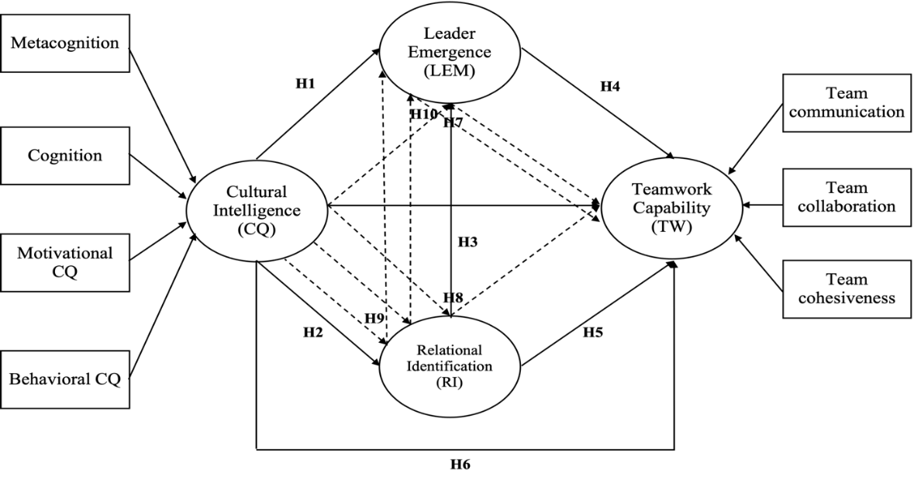
Note:
= Direct relationship hypotheses
= Mediation hypotheses
Figure 1. Research Model

References (use insert-page)
APA References to other publications must be in APA Manual 7th edition style and carefully checked for completeness, accuracy and consistency. For detailed instructions refer to “APA Citation Guide (7th edition): How Do I Cite?” or “Purdue Online Writing Lab.”
APA Style Guidelines Overview

Examples :
Achterberg, J. (1985). Imagery in healing. Shambhala Publications.
American Psychological Association. (2017). Stress in America: The state of our nation. https://www.apa.org/news/press/releases/stress/2017/state-nation.pdf
Baider, L., Uziely, B., & Kaplan De-Nour, A. (1994). Progressive muscle relaxation and guided imagery in cancer patients. General Hospital Psychiatry, 16(5), 340–347. https://doi.org/10.1016/0163-8343(94)90021-3
Ball, T. M., Shapiro, D. E., Monheim, C. J., & Weydert, J. A. (2003). A pilot study of the use of guided imagery for the treatment of recurrent abdominal pain in children. Clinical Pediatrics, 42(6), 527–532. https://doi.org/10.1177/000992280304200607
Bernstein, D. A., & Borkovec, T. D. (1973). Progressive relaxation training: A manual for the helping professions. Research Press.
Bottomley, A. (1996). Group cognitive behavioural therapy interventions with cancer patients: A review of the literature. European Journal of Cancer Cure, 5(3), 143–146. https://doi.org/10.1111/j.1365-2354.1996.tb00225.x
Cohen, M., & Fried, G. (2007). Comparing relaxation training and cognitive-behavioral group therapy for women with breast cancer. Research on Social Work Practice, 17(3), 313–323. https://doi.org/10.1177/1049731506293741
Cunningham, A. J., & Tocco, E. K. (1989). A randomized trial of group psychoeducational therapy for cancer patients. Patient Education and Counseling, 14(2), 101–114. https://doi.org/10.1016/0738-3991(89)90046-3

Appendix (use insert-page)

A1. Body text, Body text, Body text, Body text, Body text, Body text, Body text, Body text, Body text, Body text,

A2. Body text, Body text, Body text, Body text, Body text, Body text, Body text, Body text, Body text, Body text, Body text, Body text, Body text, Body text,

